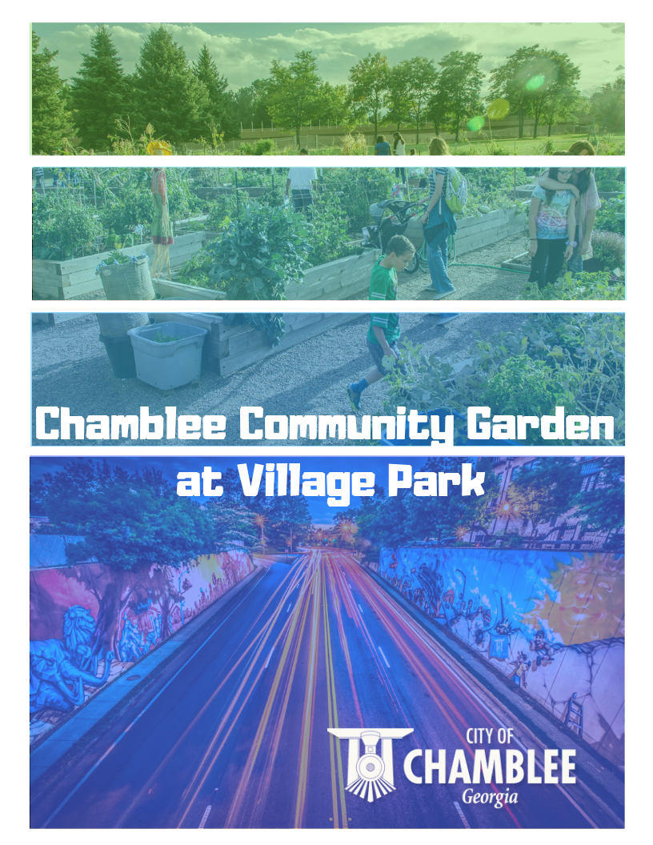

Chamblee Community Garden at Village Park

The City of Chamblee Parks & Recreation Department is the governing authority of the Chamblee Community Garden at Village Park.

- The fee for the use of the garden is $60 per plot, per year, due on or before March 1st.

- Community Garden plots will be assigned on a first-come first-served basis with priority given to city of Chamblee residents.

- Members will be assigned a specific garden plot in which they can harvest.

- Garden plot contracts are valid for 12 months.

- Members receive an access code to enter the garden during park hours.

- Gardening fees include…
Use of land
Utilities (when available)
Compost and mulch (when available)

Terms & Conditions for Participation

- Once I have been assigned a plot, I will cultivate and plant it within two weeks. I will garden year-round. My plot cannot be left unused for any period of three weeks or longer, more than one time a year.

- I will not expand my plot beyond the given space or into paths or other plots. I will keep all my plants within the limits of my garden plot and will not allow any plants to grow more than six feet high. I must keep my plot free of weeds, pests and diseases.

- I will keep my plot, paths, and surrounding areas clean and neat. I will separate my trash into three groups and put each type of trash in the designated group areas.
  - Dead plants, leaves, and other green waste plant parts
  - Rocks, stones, and asphalt
  - Paper, plastic, cardboard, wood, metal, etc.

- I will not plant any illegal plants. I will not smoke, drink alcoholic beverages, use illegal drugs or gamble in the garden. I will not come to the garden while under the influence of alcohol or illegal drugs. I will not bring weapons or pets or other animals to the garden.

- Guests and visitors, including children, may enter the garden only if I accompany them. They must follow all rules, terms, and conditions stated here. I will always supervise my children when they are in the garden. I am solely responsible for the behavior of my guests.

- I understand that Chamblee Parks & Rec. could assign me general garden maintenance tasks that I must complete.

- I will water my plot according to water-wise guidelines.

- I will attend at least two workshops or volunteer days at the Garden per growing season.

- I will not apply any pesticides in the garden without the approval of the garden manager

- I will not give out any garden lock combinations to another person.

- I will not take food or plants from other gardeners’ plots. I will not take anything from the garden that is not rightfully mine.

- I will respect other gardeners, and I will not use abusive or profane language or discriminate against others.

- I will work to keep the garden a happy, secure, and enjoyable place where all participants can garden and socialize peacefully in a neighborly manner.

Breaking any rules, terms, and conditions is cause for exclusion from the garden and loss of your plot.

- You will receive one verbal warning from the garden manager.
- If no response or correction has been made, you will receive written notice two weeks later.
- In another two weeks, if no response or correction has been made, you will receive written
- Final notification that you have forfeited your gardening privileges and plot.
- You will be allowed to reapply for another garden plot only after one year, and only at the discretion of the garden manager.

I have read accept the rules, terms, and conditions stated above for the participation in the Chamblee Community Garden at Village Park.

Signed: [Gardener] ____________________________________

Date: _______________

Approved: [Chamblee Parks & Rec.] __________________________________

Date: _______________

Chamblee Community Garden
Application

Name___________________________________________________ Date ________________

Address ______________________________________________________________________

City__________________________________________________ Zip ____________________

Phone (home)______________________________ (work) ______________________________

A plot fee of $60 is required before the plot can be assigned. This fee will go toward expenses of the community garden (water bills, plant/seed purchases, community tools, etc.).

A clean-up deposit of $150 is required before the plot can be assigned. The clean-up deposit will be returned after you have removed all your plants and cleaned your plot.

Please mark three areas that you would be interested in volunteering with during the season. Each gardener is expected to help during the season with general chores.

___Site maintenance
___Phone calls
___Mailings
___Assigning plots
___Path maintenance
___Construction projects
___Watering
___Annual planting
___Fall cleanup
___Composting
___Social events

I have read the Community Garden Rules and understand that failure to meet the guidelines will result in loss of cleanup deposit fees and gardening privileges.

Signature_______________________________________________ Date ________________

Chamblee Community Garden
Posted Rules

- The Community Garden is for designated gardeners only.

- Open dusk to dawn.

- Smoking, vaping, consuming alcoholic beverages, or the use of illegal drugs is strictly prohibited.

- Plots must be properly maintained throughout the year.
(planted, watered, harvested, weeded, mulched and free of dead plant material)

- Non-compost waste must be placed in appropriate waste containers. Approved compost waste should be placed in designated compost areas.

- Please turn off water hoses when you exit.

- Lock Up! Be sure to close the garden gate behind you.

Chamblee Parks & Recreation cannot guarantee protection against vandalism or theft. Any vandalism or theft should be reported to CPRD immediately. Any items left at the plot are at member’s own risk and will be deemed abandoned at the end of the permit term.
Community Garden Rules are subject to change at any time. CPRD reserves the right to revoke plot membership and access for failure to comply with rules.

